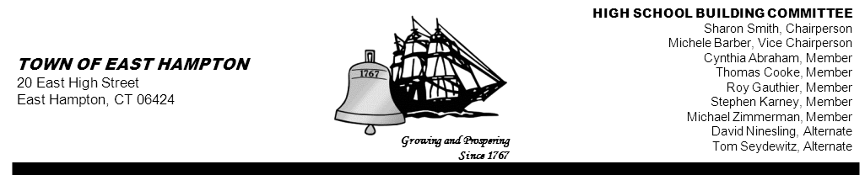

HIGH SCHOOL—ADDITION & RENOVATE-AS-NEW
BUILDING COMMITTEE MEETING
High School (Library)
15 North Maple Street, East Hampton, CT 06424
AGENDA
Thursday, February 14, 2013, 5:30 p.m.

- Call to order

- Public Remarks

- Review and approve minutes from previous meetings

- Cost Estimate Review

- Eagle Testing Update from CREC

- CREC Update

- Public Forum

- Chair’s Report

- Public Remarks

- Adjournment

cc: John Fidler Jeff Jylkka Amy Christmas
Kevin Reich James Giuliano Amy Samulson
Glenn Gemma Glenn Gollenberg Rick Herzer
Keith Klemonski Sandra Wieleba (for posting)
Michael Maniscalco Cathy Sirois (for posting)
Susan Weintraub Mark Winzler

